Controlling Molecular Orbital Gating in Molecular Junctions by One CH2 Group

*Ziyu Zhang1, Senthil Kumar Karuppannan1, Christian A. Nijhuis1,2\**

1 Department of Chemistry, National University of Singapore, 3 Science Drive 3, Singapore 117543, Singapore

2 Centre for Advanced 2D Materials and Graphene Research Centre, National University of Singapore, 2 Science Drive 3, Singapore 117542, Singapore

*Author to whom correspondence should be addressed: chmnca@nus.edu.sg

*Target journal:*

TOC: design with the scientific insights and appealing

Abstract:

**Introduction**

* Objective:
  + It has been discovered that when an electron donor (ferrocene) directly connects to an acceptor (phenyl-based aromatic unit), the molecular orbital of those two moieties can affect each other when one of them is charged. This effect is referred to intramolecular gating because part of the molecule acts as a gate electrode to affect the molecular orbital energy level of the other.
  + We are further investigating this effect by incorporating a conjugated oligophenylene ethynylene (OPE) chain as the acceptor. We have designed the structures to have varying degrees of conjugations, both within the molecules and between the molecules and the electrodes.
* What we did?
  + We have grown and characterised self-assembled monolayers (SAMs) with the structure AuTS-S-(Ph-C≡C)n-Fc (n = 1-3) and AuTS-S-CH2-(Ph-C≡C)n-Fc (n = 1-3), abbreviated as OPEn and OPEnC respectively.
  + We have fabricated the SAM-based junctions using a eutectic gallium-indium alloy (EGaIn) as the top electrode (Figure 1) and measured their J-V response at -1 to +1 bias. We have then systematically studied the temperature dependency of the charge transport in these junctions and obtain the activation energies across this bias window.
  + The bias dependence of the activation energy *Ea* shows a bell-shaped relationship, which does not fit into either Landauer or Marcus theory. This phenomenon can be explained by the work of Nitzan.
  + In the neutral stage of the molecules, the LUMOs are more than 2 eV apart from the Fermi level of studied metals. However, we believe when the Fc group is charged in the negative bias, the LUMO can be gated into the conduction window and give rise to the inverted Marcus regime charge transfer.
  + Why is it important?
  + The conjugated backbone based on OPE units is more rigid and gives rise to more robust monolayers in comparison to aliphatic SAMs such as FcC11SH. They have the potential to be used to studies where molecular orientations are important.
  + We have demonstrated that by adding one CH2 unit we can significantly change the coupling strength between the OPE and the Au electrode. As a result, the charge transfer mechanism can change from normal Marcus regime to the inverted Marcus regime.

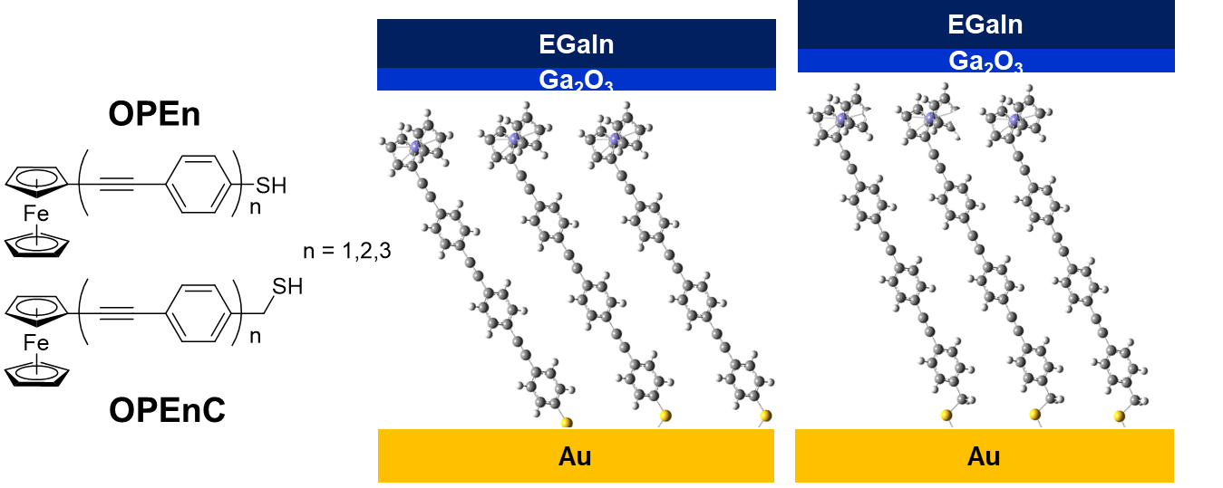

Figure 1. The schematic illustration of the junctions AuTS-S-(Ph-C≡C)n-Fc//EGaIn (n = 1-3) and AuTS-S-CH2-(Ph-C≡C)n-Fc//EGaIn (n = 1-3).

**Results and Discussion**

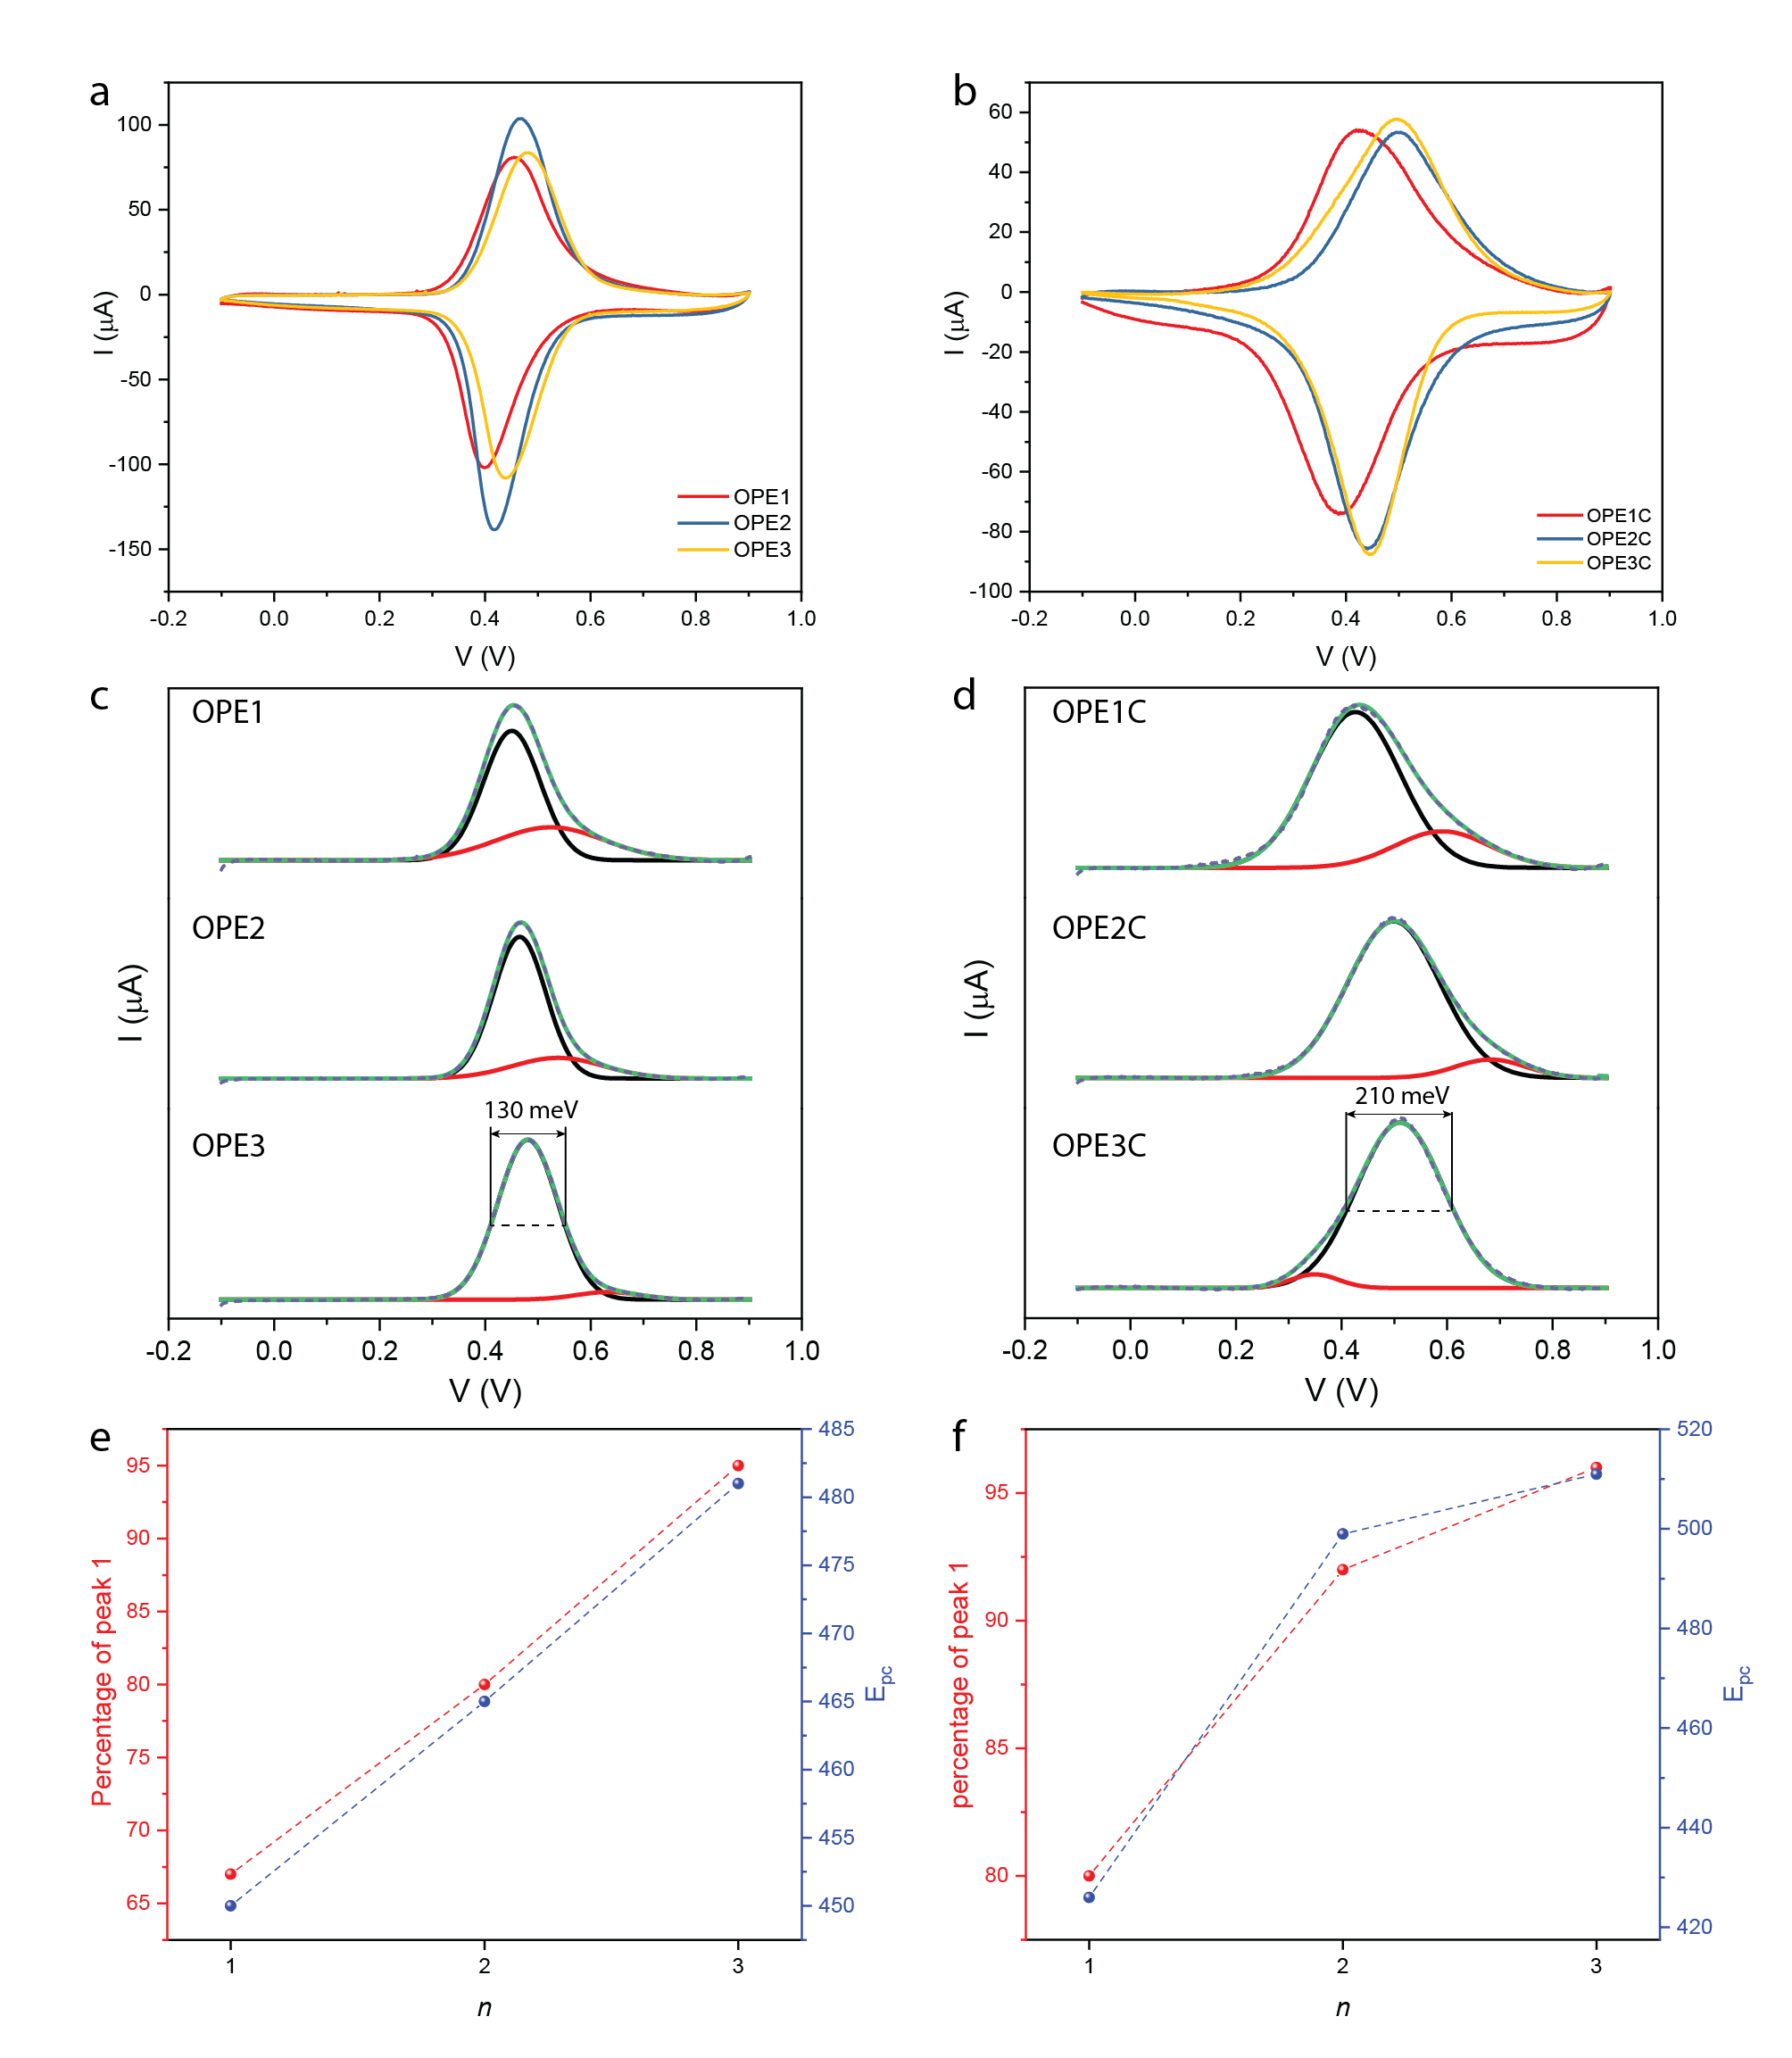

Figure 2. Surface characterisation of studied SAM: Cyclic voltammograms of (a) OPEn and (b) OPEnC measured at a scan rate of 1 V/s. Deconvolution of the anodic peak of (c) OPEn and (d) OPEnC, all peaks were fitted with Gaussian function. The percentage of the main peak and the anodic potential Epc of (e) OPEn and (f) OPEnC as a function of the n.

* To characterize the structure of the SAMs, we performed cyclic voltammetry of the SAMs OPEn and OPEnC. Figure 2 shows the voltammograms and the analysis of the anodic peak for the ferrocene groups.
* Figure 2(a) and (b) shows that for all the SAMs in this study, a characteristic ferrocene redox wave is present at 0.4-0.5 V. The peak deconvolution in Figure 2(c) and (d) shows that for all SAMs, there is a main peak representing the Fc groups in a well-packed SAM, and a small peak likely comes from the physisorbed molecules. In Figure 2(e) and (f), we can observe higher percentage of the main peak up to more than 95% with the increasing number of OPE units, indicating the longer molecules pack in a more uniform manner. We attribute this phenomenon to the stronger π-π intermolecular interaction between the OPE units.
* In addition, the full width at half maximum (FWHM) values for the main anodic peak are ~130 meV for OPEn and ~210 meV for OPEnC. The FWHM for SAMs are determined by the electrostatic interaction between each molecule in the redox process. The larger FWHM values in SAMs of OPEnC also suggest that the molecules are closer to each other and have stronger repulsion when the ferrocene group are charged in the cyclic voltammetry process. We believe the CH2 units weaken the Van Der Waals interaction between OPE and metals and give more freedom for the molecules to pack into monolayers.

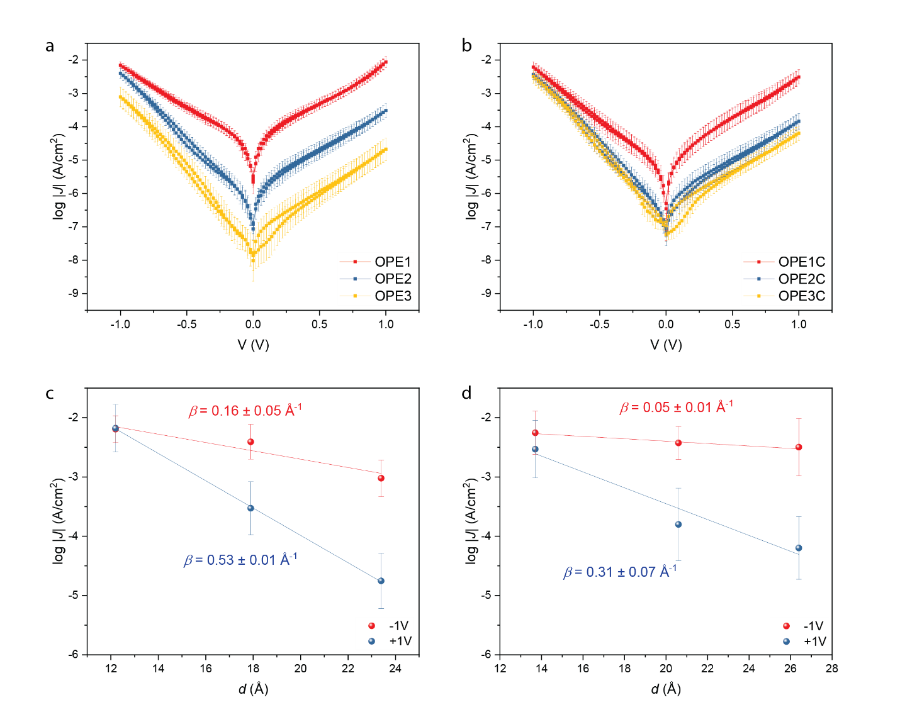

Figure 3. The Gaussian log-normal average current density as a function of voltage for (a) OPEn and (b) OPEnC. The error bar represents the 95% confidence interval from more than 400 data points. The current density at – 1V and + 1V bias as a function of the molecular length for (c) OPEn and (d) OPEnC. The molecular length was determined by CPK model.

* We measured the *J*-*V* response of the junctions based on SAMs OPEn and OPEnC. The top electrode is a cone-shaped tip of EGaIn. The Gaussian log-normal average current density as a function of voltage is shown in Figure 3.
* At +1 V bias, the *β* values agree well with the other published values in several similar conjugated systems (0.3-0.5 Å-1). The charge transport mechanism is believed to be off-resonant coherent tunnelling. At -1 V bias, *β* becomes smaller and similar to what have been observed for long conjugated chains, indicating the mechanism has switched to hopping.
* Here it is worth noting that the general tunnelling equation assumes a constant tunnelling barrier when changing the tunnelling distance. But in a conjugated system, the tunnelling barrier is affected by both the molecular length and the coupling strength of the molecular HOMO and the metal electrodes.
* When n = 1, the ferrocene group strongly couples with the bottom electrode. When n = 3 this coupling *Γ*bottom is much weaker. On the other hand, *Γ*top is determined by the Van Der Waals interactions between ferrocene and the EGaIn and do not change significantly with n. When a -1 V bias is applied to the junction, the HOMO movement is more prominent for OPE3 and OPE3C. As a result, the HOMO of the longest molecules enters the conduction window at the lowest bias despite that they are further away from the Fermi level at zero bias.
* Figure 3(c) and (d) shows *β* values for OPEnC SAMs are smaller than those for OPE SAMs at both biases. One possible explanation is that for OPEnC, the *Γ*bottom is smaller due to the conjugation breaker unit -CH2-. So at -1 V bias the HOMO level are closer to the top electrode, further reducing the tunnelling barrier.

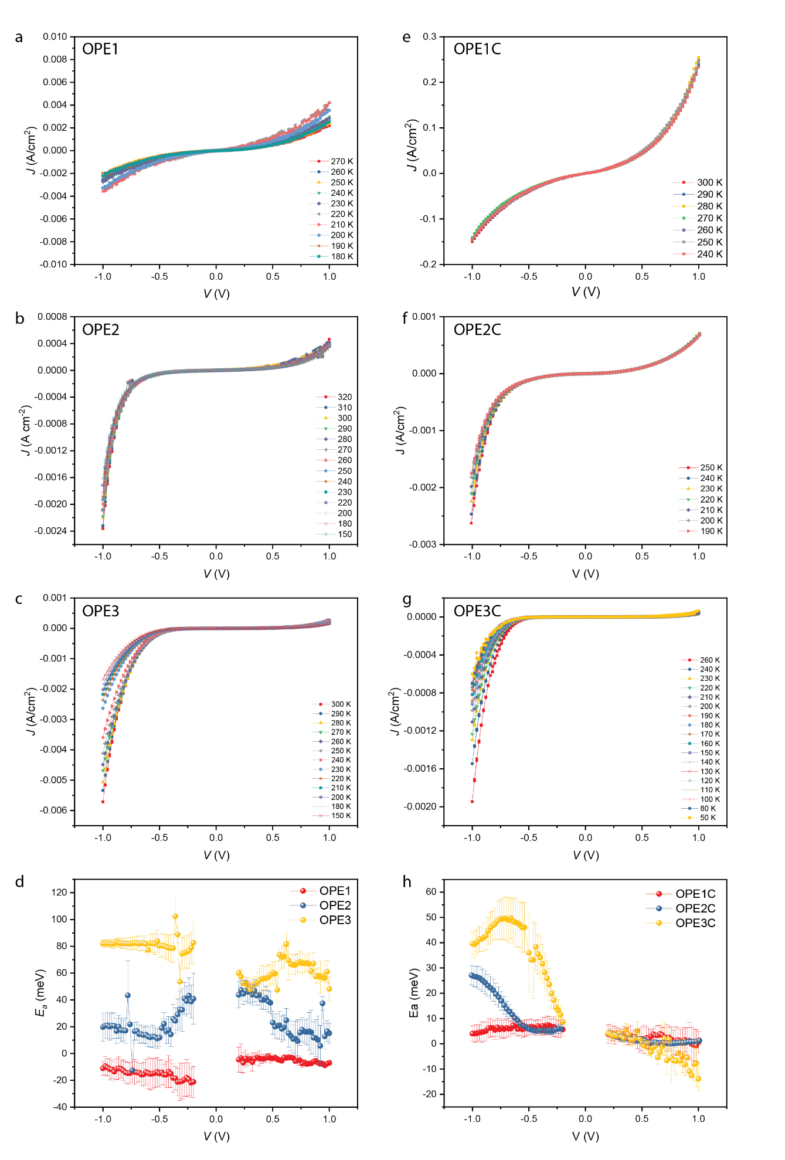

Figure 4. The temperature-dependent *J*-*V* curve for SAMs of (a)-(c) OPEn, n = 1-3 and (e)-(g) OPEnC, n = 1-3. The activation energy *Ea* as a function of voltage for (d) OPEn and (h) OPEnC. The error bars represent the standard deviations of data sets from three different junctions.

* To investigate the temperature dependency of the charge transport in these junctions, we stabilized EGaIn in a microfluidic channel to enable J-V measurements in vacuum and low temperature. The details about the device to be added by Senthil. The results are shown in Figure 4.
* Figure 4 (a) – (c) and (e) – (g) shows the *J*-*V* response of the junctions. The current densities of the junction are within one standard deviation of those from the same junctions using cone-shaped EGaIn tips as the top electrodes. The rectification ratios of the junctions remain the same as the result showed in Figure 3, indicating the rectification is caused by the molecules themselves. I cannot tell there is a shape difference by eye but I have not done shape analysis like NDC for all junctions.
* Figure 4 (d) and (h) shows the activation energy of the charge transport process as a function of bias voltage. The data from -0.2 V to +0.2 V was omitted because they are affected by capacitive current and does not provide insights for our discussion.
* For OPE1 and OPE1C, the charge transport process is virtually activationless (*Ea* ≈ 0), indicating coherent tunnelling. Another possibility is the leakage currents dominates for these junctions because the molecules are short and the SAMs are more prone to defects.
* For OPE2 and OPE3, a constant *Ea* was observed across the bias window, indicating hopping is the primary charge transport mechanism in these junctions. Longer chain length in OPE3 allows more time for the electrons to relax on the molecules, giving rise to higher activation energy. I could just use the data from 0.5 V and -0.5 V and the trend would look much cleaner.
* For OPE2C and OPE3C, a bell-shaped curve of *Ea* vs *V* is observed at negative voltage. This behaviour was predicted by Migliore et al. using a model based on Marcus theory applied in tunnelling junctions. It was later proven experimentally that the involvement of LUMO can push the charge transport into inverted Marcus regime. Here the position of the peak could represent the bias when both the HOMO and LUMO of the molecules are in the conduction window. The peak *Ea* values (30 - 40 meV) are lower than those for a typical hopping mechanism. We attribute this low *Ea* to the effect of nuclear tunnelling. The strong coupling between the ferrocene and the phenylene ethynylene units can make the charge transfer become non-adiabatic, lower the effective reorganization energy *λ*\*.

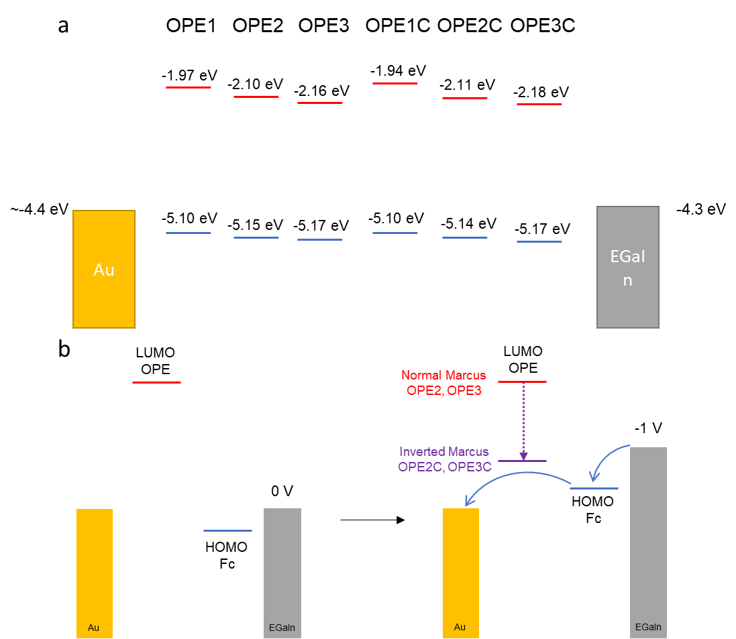

Figure 5. (a) The energy level alignment in the junctions. (b) The change of charge transport mechanisms when -1 V bias is applied to the junctions. The HOMO levels are determined by UPS, and the LUMO levels are determined by UPS and UV-Vis spectrum.

* Figure 5(a) shows the energy level alignment of the junctions at zero bias. The HOMO of the molecules locates at the Fc groups while the LUMO locates at OPE. The HOMOs are about 0.7 – 0.8 eV apart from the Fermi level of Au and they are expected to enter the conduction window at negative bias. The LUMOs are more than 2 eV higher than the Fermi levels. Without strong interactions between OPE and Fc, or enough time for the electrons to stay on the molecules, these LUMOs should not participate in the charge transport.
* Figure 5(b) shows that when -1 V bias is applied to the junction, the HOMO enters the conduction window. The Fc group can be charged due to its tendency to lose one electron to form ferrocenium (Fc+). This charged Fc+ can reduce the energy level of the LUMOs on the OPE part of the molecule, making the LUMO inside of the conduction window as well. This intramolecular gating effect pushes the charge transport mechanism to the inverted Marcus regime and results in the bell-shaped curve of Ea in Figure 4(h).
* In OPE2 and OPE3, the molecular orbitals can delocalize through the sulfur atom and to the metal density of states. This strong coupling makes the electrons quickly dissipate to the metal. There is now enough time for the “gating” effect to take place. In these two systems the charge transport operates in the normal Marcus regime.

**Conclusions**

* We have again proven that inverted Marcus charge transfer can be realized via intramolecular gating. In addition, we have shown that this phenomenon can only occur if the molecules are weakly coupled to the electrode. We have demonstrated that one CH2 group to disrupt the conjugation between the molecules and the electrode can change the charge transport mechanism from normal Marcus regime to the inverted Marcus regime. Inverted Marcus transfer can make the electron transport activationless and have potential in energy saving in electric circuits. The possibility to fine-tune this mechanism could have profound implications for researchers to further explore this type of systems.